|  |  |  |
| --- | --- | --- |
| **Global Information Security** | | |
|  | **[ ] Vendor Scoping Questions** | |
| Effective (Issue) Date: | 6/6/2017 |
| Next Review Date: | TBD |
| Status: | Approved |
| Classification: Internal | Internal |
| Document Owner: | CISO |
|  |  |

**Objective**

This set of questions will allow Information Security to determine a vendor’s risk profile based on the Confidentiality, Integrity and Availability requirements for classified data (Confidential, Internal, and Public) identified in the Vendor Request Checklist and Client Scoping Questionnaire. Conclusions drawn will determine the depth of risk assessment questions the vendor will receive, in addition to required documents that the vendor must provide based on security requirements defined in Laureate’s Policies:

* Information Security Policy
* Password Policy
* Control Management Policy
* Back and Recovery Policy
* Business Continuity and Disaster Recovery Policy
* Encryption Policy
* Access Management Policy
* Network Security Policy
* Incident Response Process Policy
* Physical and Environmental Security Policy
* Remote Management Policy

|  |  |
| --- | --- |
| **Vendor Information** | |
| Vendor Name: | e-diploma |
| Vendor POC: | www.e-diploma.com.br |
| Project Name: | e-diploma |
| Data Classification | Confidential |
| Date: | 9/12/2019 |

Questions to safeguard Confidentiality

1. Do you have processes in place to prevent other companies or 3rd parties from accessing Laureate’s data?

Answer: Yes. We have password and permission policies within our application and infrastructure.

1. What authentication protocols are in place (username/password, MFA)?

Answer: Login and password. The implementation of other security layers with MFA is under study.

1. Are anti-virus/anti-malware software and signatures up to date?

Answer: Yes.

1. Do you have Encryption at rest and/or Encryption in transit capabilities? (Based on project)

Answer: Yes.

1. Do you have breach notification program

Answer: Yes.

**Comments:**

**Conclusion:**

Choose an item.

Questions to safeguard Integrity

1. Where specifically is the information processed and stored?

Answer: Inside data center on application and database servers.

1. Who has access to the system(s) or data?

Answer: Only authorized application users and authorized server and database administrators.

1. How do you prevent other clients from accessing Laureate data? (Show us)

Answer: Each login only sees data belonging to that educational institution, as shown by the evidence below on our homologation servers:

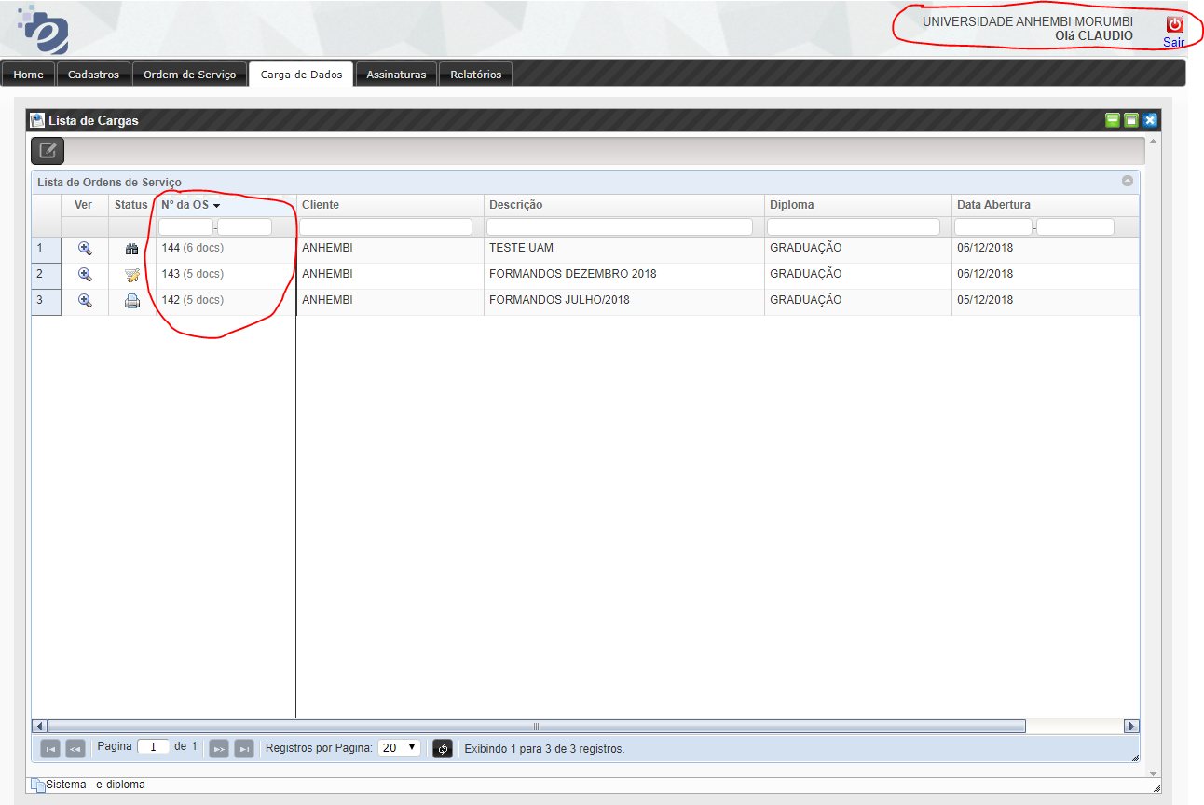

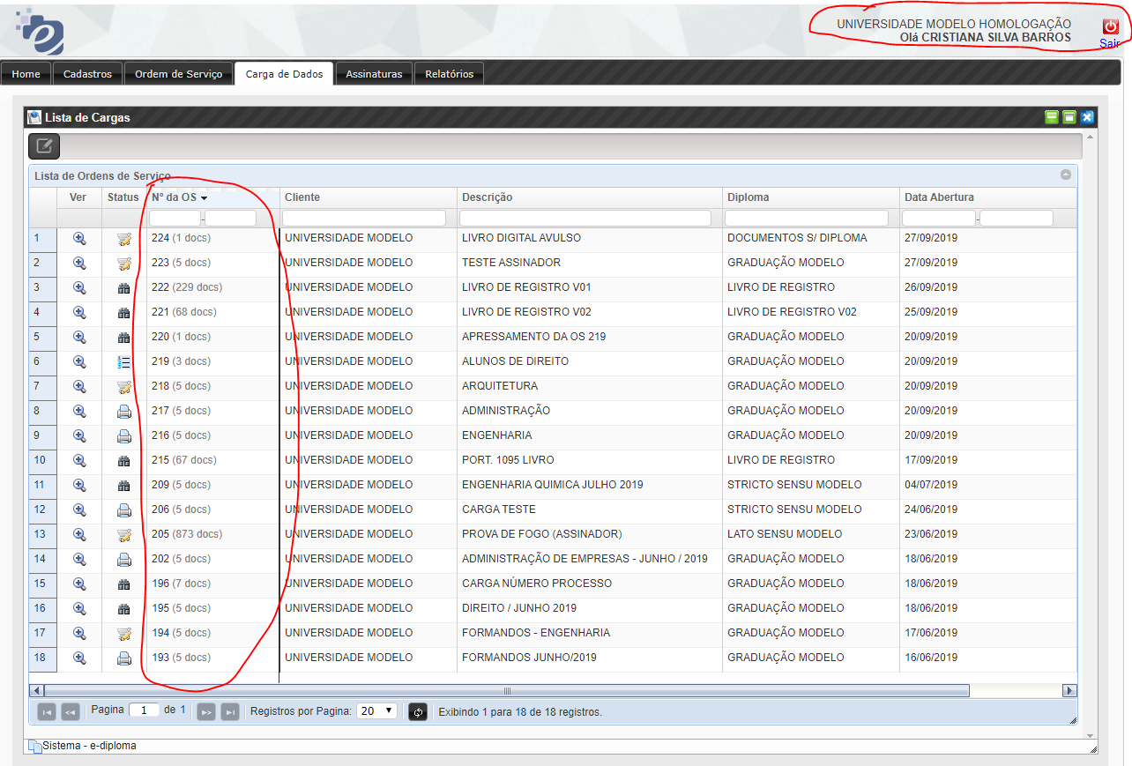

1. What type of physical security measures are in place? (Show us)

Answer: Our servers are hosted in a data center with digital certificates and protection software.

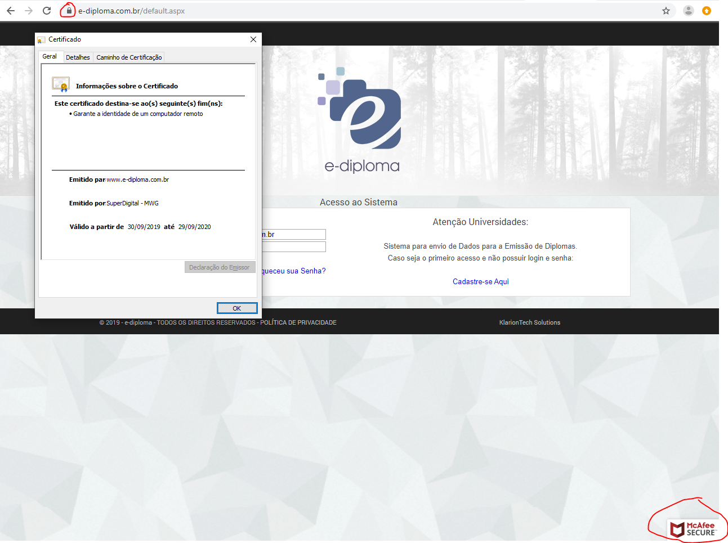

1. What type of controls are in place for employees who have access to systems and data?

Answer: There is a manager module to manage the access and configuring the features that the user will have access to, and can make locks and cancellations on your login.

1. How many employees have remote access to the system?

Answer: Authorized Users Only.

1. What are the requirements for passwords? (How is it implemented, show us)

Answer: Currently we have only restriction on the minimum amount of characters.

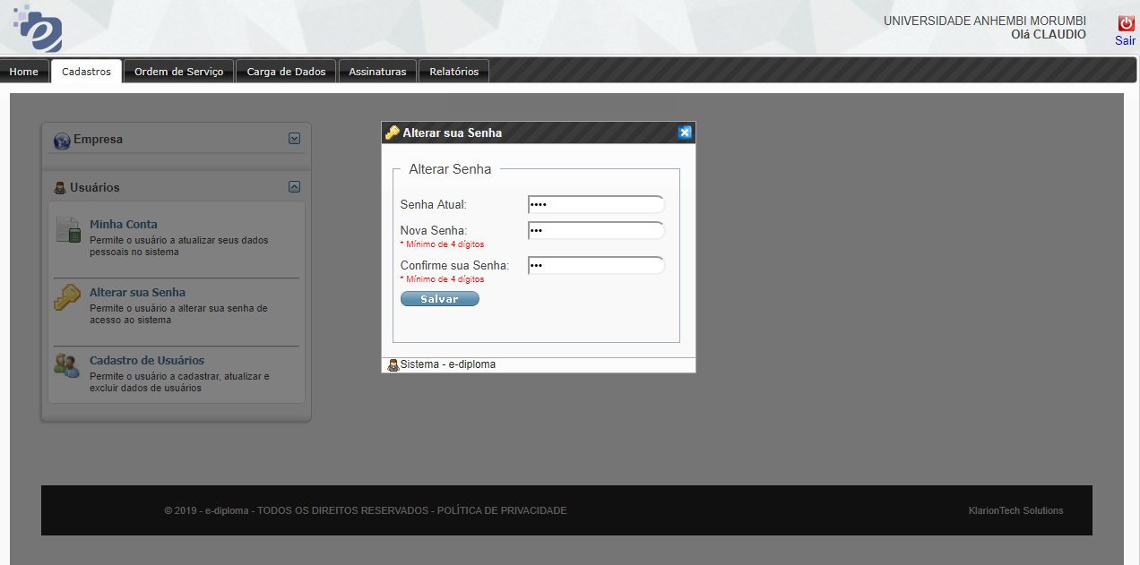

**Comments:**

**Conclusion:**

Choose an item.

Questions to ensure Availability (RTO and RPO)

1. In the event the system experiences downtime, what is the process for communicating this occurrence and what available options can be provided? (Walk us through the process)

Answer: System users will be notified by email, and we will use features to enable server mirroring.

1. How long would it take to bring the system back up if an outage were to occur?

Answer: 8 hours maximum.

1. What type of infrastructure is in place to provide redundancy? (Walk us through the process)

Answer: We have servers on different sites with redundant data.

**Comments:**

**Conclusion:**

Choose an item.

**Summary Conclusion:**

**Vendor Risk Profile:** Choose an item.